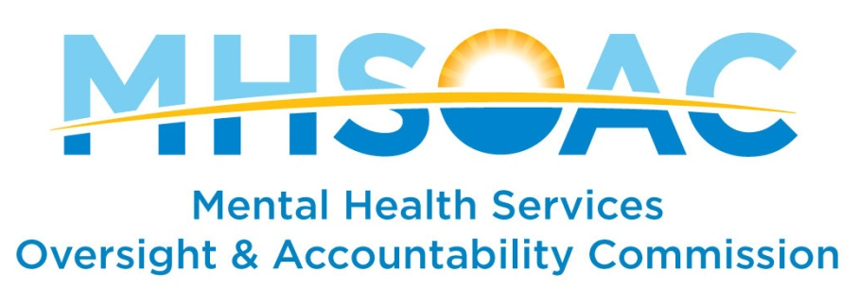

STAFF ANALYSIS—LOS ANGELES COUNTY

Name of Innovative (INN) Project: Mobile Transcranial Magnetic Stimulation
Total INN Funding Requested: $2,388,268
Duration of Innovative Project: Three (3) Years

Review History:
Approved by the County Board of Supervisors: Pending MHSOAC Approval
County submitted Innovation (INN Project): December 5, 2017
MHSOAC consideration of INN Project: February 22, 2018

Project Introduction:
In order to reduce symptoms in clients with major depressive disorders, Los Angeles County proposes to develop and implement a Mobile Transcranial Magnetic Stimulation (TMS) Program for clients who have a history of being resistant to treatment and live in county contracted Board and Care (B&C) facilities within the County.
The County states that providing TMS treatment for those residing in B&C facilities allows residents to receive treatment, on a consistent basis without interruption, because the treatment would be brought directly to their place of residence. The goal of this project is to focus on B&C residents with treatment refractory depression with the hopes of increasing their social and occupational functioning. Treatment refractory depression, also known as treatment resistant depression, is a term used in clinical psychiatry to describe cases of major depressive disorder that do not respond adequately to appropriate courses of at least two antidepressants.
TMS treatment is still relatively new and there is still much to learn, and although it appears to be safe, it is uncertain whether or not side effects may present themselves in the future. The County may wish to be prepared to discuss possible side effects that may develop in the future, if known.
In the balance of this brief we address specific criteria that the MHSOAC looks for when evaluating Innovation Plans, including:
- What is the unmet need that the county is trying to address?
- Does the proposed project address the need?
- Are there clear learning objectives that link to the need?
- Will the proposed evaluation allow the county to make any conclusions regarding their learning objectives?
In addition, the MHSOAC checks to see that the Innovation meets regulatory requirements, that the proposed project aligns with the core MHSA principles, promotes learning, funds exploration of a new and/or locally adapted mental health approach/practice, and targets one of the four (4) allowable primary purposes.

The Need
Los Angeles County states that approximately 4.2 million Americans are diagnosed with treatment refractory depression (as defined above). The County indicates they treated approximately 42,000 individuals for major depressive disorder within Fiscal Year 16/17; and an additional 23,000 individuals received treatment in which depression was part of their primary mental health diagnoses.
The County estimates that approximately 35% (n=22,750) of the 65,000 individuals being treated for depression are in treatment refractory and do not respond to medication and/or therapy. Additionally, the County indicates there are about 4,000 individuals residing within B&C facilities who received mental health treatment during FY 16/17, and approximately 24% (n=960) have a primary diagnosis of major depressive disorder and another 29% (n=1160) had a primary diagnosis of either bipolar or schizophrenic disorder in which depression plays a factor.
The County states individuals with severe chronic mental illness need high levels of mental health care and as a result, some of these individuals are unable to care for themselves and require residing in B&C facilities to receive proper care and supervision. The County feels individuals living in B&C facilities would benefit from receiving TMS treatment due to their limited functioning. Furthermore, the mobility aspect of this project allows for adherence to treatment since the County will be providing treatment at the B&C where the individual resides.

The Response
To address these issues, the County is proposing to implement Mobile Transcranial Magnetic Stimulation (TMS) in order to provide treatment for individuals living in B&C facilities who meet the criteria of being in treatment refractory. Los Angeles proposes to purchase a TMS device, accessories for the device, and a modified van that will transport the TMS equipment to those residing in B&C facilities that agree and volunteer to participate in treatment.
A lead psychiatrist will provide oversight of initial TMS treatment sessions, provide outreach and education at B&C facilities and determine if referred patients meet the criteria to receive TMS treatment. The County will hire and train staff consisting of a Psychiatric Technician and a Nurse who will operate the equipment. The County indicates treatment sessions will typically last anywhere from 10-45 minutes and is administered once daily for five (5) consecutive days for a four (4) to eight (8) week period. Exact treatment protocols and durations will vary depending on the response to treatment.
During treatment, sedation or general anesthesia is not required, so the patient is awake and alert and will be in a seated/reclined position. The electromagnetic coil rests directly on the temporal lobe, where the TMS device generates magnetic fields that ultimately adjust the electrical activity of neurons. Patients will be required to remove any magnetic-sensitive objects and wear ear plugs as the patient will hear an audible clicking sound, similar to a Magnetic Resonance Imaging (MRI) machine, and may feel a rhythmic tapping sensation underneath the coil. After treatment, the patient may resume their normal daily activities immediately as there is no recovery time.

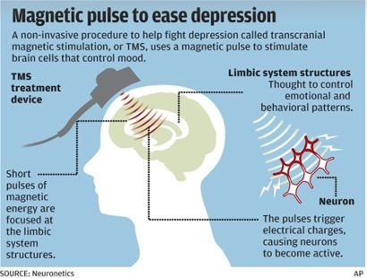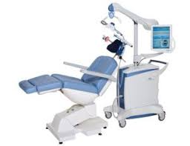

Research shows that the most serious risk of TMS treatment is seizures, although the risk is extremely low. The County states individuals with a history of seizure disorder or those with metal implants in the head or upper torso (such as a pacemaker), will be excluded from receiving TMS treatment due to the risks involved. Some reports indicate that although TMS may produce discomfort, it is safe and has proven to be effective. Typical side effects may include headache, scalp discomfort at the stimulation site, and tingling or twitching of facial muscles.
During the Community Planning Process, clarification was asked of the County to distinguish the difference between TMS and Electroconvulsive Therapy. Research provides stark differences between these two (2) types of treatments:
Electroconvulsive Therapy (sometimes referred to as shock therapy):
- Cranial therapy used to treat mental illness or mood disorders
- Utilizes an electric current
- Usually administered in a hospital setting
- Various side effects, some as serious as memory loss
- Patients are given muscle relaxants to prevent damage to muscles and bones
- Patient is under general anesthesia
Transcranial Magnetic Stimulation:
- Cranial therapy used to treat mental illness or mood disorders
- Non-invasive
- Usually administered in doctor’s office or outpatient setting
- Typically has no side effects
- No medication is needed to relax patients
- Patient is alert and awake during therapy
The County states there were key factors in selecting the target population of individuals residing in B&C facilities. Individuals with serious mental health problems are unable to live independently and ultimately reside in a B&C facilities for support. The County indicates residents living in B&C facilities have difficulty adhering to treatment and access to TMS Treatment is another barrier that may be alleviated with this project. If this project proves to be effective and successful, the individuals residing in these B&C facilities may progress to live a life of independence without the symptoms of major depressive disorder. County indicates approval from Institutional Review Board is not needed; however, the County may wish to be prepared to provide rationale for not seeking approval for study involving human subjects.

The Community Planning Process
To facilitate culturally diverse stakeholder involvement, the County states they assembled a 58-member System Leadership Team (SLT) to provide input related to the various stages of planning surrounding innovation projects. The County indicated the planning of this project began in Spring 2017 and was presented to the SLT in October 2018, receiving positive feedback.
There was interest from stakeholders involving the expansion of this Innovation Project to include target populations beyond those currently residing in B&C facilities; however, it was explained that the possibility of expansion is determined upon the data collected and overall success of the project. Additional feedback received during the Community Planning Process (CPP) included concern regarding possible side effects of treatment, other viable funding sources, and the difference between TMS and Electroconvulsive Therapy (explained above).
The County states that substantive feedback was considered and incorporated into the
Innovation Project, or will be incorporated during implementation of the project. Furthermore, Los Angeles states they will solicit peers from their peer resource center who have undergone TMS treatment and have achieved positive results in an effort to provide information, support, and share their lived experience for those who are contemplating this type of treatment. The County may wish to discuss and provide clarity on the role of peers and indicate if they will be compensated.
The MHSOAC shared this Innovation Project with stakeholders beginning January 19, 2018 and received three (3) comments from the public in response, yielding both positive feedback in addition to general questions and concerns as summarized below:
- Feedback received indicating TMS treatment as promising but cautions that treatment is still new and potential long term side effects are not known at this time
- Feedback received stating TMS treatment is innovative and appreciative that treatment is being made available to consumers in the public sector. Concern was expressed that the role of peers is marginalized in this plan and funds have not been allocated within the budget to support peer involvement.
- Feedback received with various questions including, but not limited to: cost per patient, rationale behind Innovation Project being mobile, type of TMS being utilized, cost of the TMS machine, program assessment during and after implementation, concern to ensure the reliability and validity of results, and the criteria used for the selection of patients to participate in the project.
Additionally, the MHSOAC shared the feedback that was received, in redacted form, with the County on February 1, 2018.

Learning Objectives and Evaluation
Los Angeles County has proposed implementing a Mobile Transcranial Magnetic Stimulation (TMS) program to treat psychiatric disorders within the county. The project outlined has been identified as a three (3) year demonstration project with a goal of improving the quality of mental health services for clients with chronic and severe mental illness who are medication resistant/refractory.

The County will provide TMS treatment in a modified van, enabling psychiatrists to meet and provide treatment to individuals residing in Board and Care facilities (B&C). The County will target individuals residing in B&C facilities with treatment refractory depression—defined as “having an inadequate response to at least two antidepressant medications at adequate dose and duration, or an inability to tolerate such medications.” Additionally, the County will target individuals in B&C facilities that meet one or more of the following:

- Resistance to treatment with psychopharmacologic agents as evidenced by a lack of a clinically significant response to at least two psychopharmacologic agents in the current depressive episode; or
- An inability to tolerate psychopharmacologic agents as evidenced by two trials of psychopharmacologic agents from two different agent classes; or
- A history of response to TMS in a previous depressive episode; or
- A history of response to Electroconvulsive Therapy (ECT)

The County states that patients that are taking medications will not be excluded, and will continue their medications during treatment. The County may wish to identify how any positive outcomes, as a result of treatment, can be attributed to TMS, current medications, or both. The County estimates serving a total of 284 clients per year among 8 different B&C facilities.

The evaluation of the TMS program revolves around four main learning questions:

- Will these individuals be adherent with a mobile TMS treatment program?
- Is TMS an effective treatment for this population?
- Does TMS for depression lead to improvement in comorbid symptoms (i.e., substance use, psychotic symptoms, etc.)?
- If TMS is an effective treatment for this population, should the program be expanded to treat a larger part of the population?

In order to measure outcomes relative to the proposed learning questions, the County will utilize weekly symptom and functional based measures to track treatment progress. Specifically, the Mental Health Counselor, RN will administer the Quick Inventory of Depressive Symptoms (QIDS-16, patient rated), the Hamilton Depression Rating Scale (HDRS, clinician rated), and other measures for adaptive daily living, quality of life, and satisfaction with TMS. Outcomes from these tools will track:

- A reduction in depressive symptoms
- An increase in social and occupational functioning
- An increase in adherence to treatment
- A decrease in utilization of emergency services among high utilizers using data 6-months prior to TMS treatment and 6-months post TMS treatment.
- An increase in wellbeing as evidenced by an increase in social connectedness and engagement in meaningful activities.

The Budget
The proposed budget for this Innovation Project is $2,388,268 over a three (3) year project duration. The majority of the budget is allocated towards direct administrative personnel costs which accounts for $2,205,640 (92%) of the total budget. Staff required for this project will include a Mental Health Psychiatrist, a Mental Health Counselor (RN), a Clinical Psychologist II, a Psychiatric Technician II, and an Intermediate Typist Clerk.
The County will make one-time purchases totaling $164,628 (6.9%) to purchase a modified van ($89,195) that will transport the treatment equipment (TMS device: $69,433 ; laptop: $2,000) to contracted board and care facilities within Los Angeles County. The one-time purchase will also include an operating cost of $4,000 which will cover the cost of space, computer and equipment for the Clinical Psychologist II whose primary work station will not be in the van containing the treatment equipment. The budget costs for the maintenance of the van is $18,000 (0.75%), or $6,000 per fiscal year.

The County indicates the Clinical Psychologist II will be responsible for the collection, analysis, and dissemination of data that may contribute to statewide learning. Additionally, findings related to best practice guidelines and implementation efficacy will be shared with the mental health community with the desire to possibly expand the project within Los Angeles County, as well as other counties and states. The evaluation component will also be completed by the Clinical Psychologist II and is included as part salary ($401,590, 17% of total budget).

Los Angeles County indicates that progress and collected data will be analyzed by the steering committee and county staff, and if new populations are identified based on collected data, those target populations would be included during project implementation. County may wish to address if they have sufficient funds allocated for the inclusion of a new target population during implementation of this project and if peers used in the project will be compensated.

Regarding sustainability, the County states a final determination will be made at the end of the third year of the project and is contingent upon the overall success, effectiveness and evaluation of the project. The County indicates they may elect to continue services and staff through the use of MHSA Community and Services Supports (CSS) funds.

Additional Regulatory Requirements
The proposed project appears to meet the minimum requirements listed under MHSA Innovation regulations.
Note: If Innovation Project is approved, the MHSOAC must receive certification of approval from the Los Angeles Board of Supervisors before any Innovation Funds can be spent.

References
https://en.wikipedia.org/wiki/Treatment-resistant_depression

https://www.hopkinsmedicine.org/psychiatry/specialty_areas/brain_stimulation/tms/faq_tms.html

http://www.tmsaugusta.com/depression-painful-tms-painful/

https://www.mayoclinic.org/tests-procedures/transcranial-magnetic-stimulation/about/pac-20384625

http://www.cochrane.org/CD006081/SCHIZ_transcranial-magnetic-stimulation-tms-treatment-schizophrenia

http://tmsmind.com/tms-therapy/tms/ect-vs-tms/

