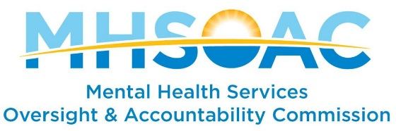
Parents/Caregivers of Children and Youth Information Questions
The purpose of this survey is to ascertain the focus and work of organizations that are currently supporting Parents/Caregivers of Children and Youth with accessing mental health services, advocating on behalf of relevant mental health and wellness services, providing education and training, conducting outreach and engagement, and research and evaluation on the needs and services for Parents/Caregivers of Children and Youth.
Your responses will help inform the facilitation of a community listening session designed to support stakeholder advocacy on behalf of Parents/Caregivers of Children and Youth in California.
Electronic and in-person feedback will inform the process as we create a Request for Proposal (RFP) for Parents/Caregivers of Children and Youth. A list of information questions is included below. Please email responses to MHSOAC Stakeholder Advocacy Lead Michele Nottingham, at: michele.nottingham@mhsoac.ca.gov.
Please include in the subject line “Parents/Caregivers of Children and Youth Stakeholder RFP.”
 | Question | Response
1 | Please tell us what your organization does to advocate for the mental health needs of Parents/Caregivers of Children and Youth. Examples include:  - Interaction with state-level decision makers (e.g. legislators)  - Interaction with local-level decision makers (e.g. county behavioral health leadership, board of supervisors, etc.)  - Conduct training  - Provide resources and services  - Outreach  - Other
2 | How long has your organization been in existence?
3 | What are the four most critical needs for Parents/Caregivers of Children and Youth?
4 | How do you determine the most critical needs?
5 | How do you determine your success in meeting the needs? What types of data do you collect?
6 | What counties, regions, or areas of the State do you serve?
7 | Where are you physically located in the State? List all locations.
8 | Do you collaborate with other organizations? Please explain the purpose or function of the collaborations and the length of time in existence.
9 | How is your organization funded? Local, state, Federal, private, other.
10 | What are your most effective tools in reaching the target population?  (e.g. Community Forums, social media, ambassador/liaison, focus groups)

